WEB DEVELOPMENT PORTFOLIO
Shazil Ahmed Shaikh
Selected website, platform, and digital product projects

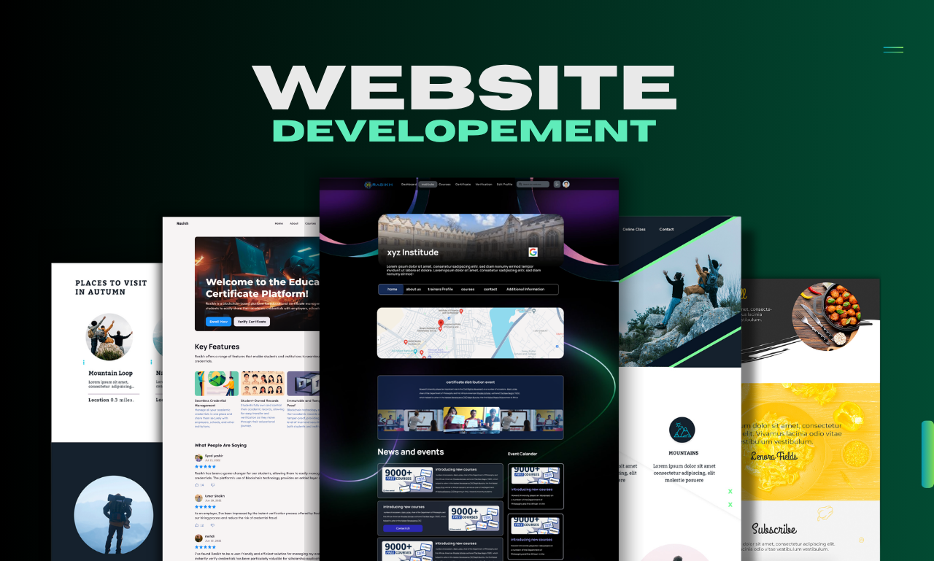
This document presents a unified snapshot of web development work with a focus on modern UI design, scalable backend architecture, business-oriented workflows, and production-ready implementation.

Portfolio Summary
The portfolio brings together full-stack and front-end centered projects that show range across service marketplaces, business websites, responsive landing pages, admin systems, and real-time user experiences.
Core strengths
- Responsive web design and polished visual presentation
- Backend integration for payments, dashboards, workflows, and APIs
- CMS and framework-based development for maintainable builds
- Conversion-focused layouts for service and business websites
- Production-minded delivery with deployment and runtime considerations
Technology profile
Frontend: HTML, CSS, JavaScript, React, Tailwind, Bootstrap
Backend: Django, Flask, PHP, Node.js, Firebase
Data and services: PostgreSQL, MongoDB, Stripe, Cloudinary, WebSockets, REST APIs
Tools and delivery: WordPress, GitHub, Docker, Nixpacks, Railway, Daphne

1. SPHERE - Service Marketplace Platform
SPHERE is a Django 5 marketplace platform built for service booking, provider operations, payment handling, and live communication between customers and service providers.
What it delivers
- Customer booking lifecycle with checkout and status management
- Stripe payment flow with payout tracking and reconciliation
- Provider product marketplace with cart and inventory handling
- Real-time chat and notifications through Channels/WebSockets
- Admin workflows for approvals, exports, promotions, and operations
Implementation highlights
- Django 5, PostgreSQL, Channels, Daphne, and Stripe integration
- Separate app structure for main pages, customers, and providers
- WebSocket-based messaging and notification support
- Background commands for reminders and data operations
- Deployment-ready runtime configuration with ASGI and health checks
Visual snapshot
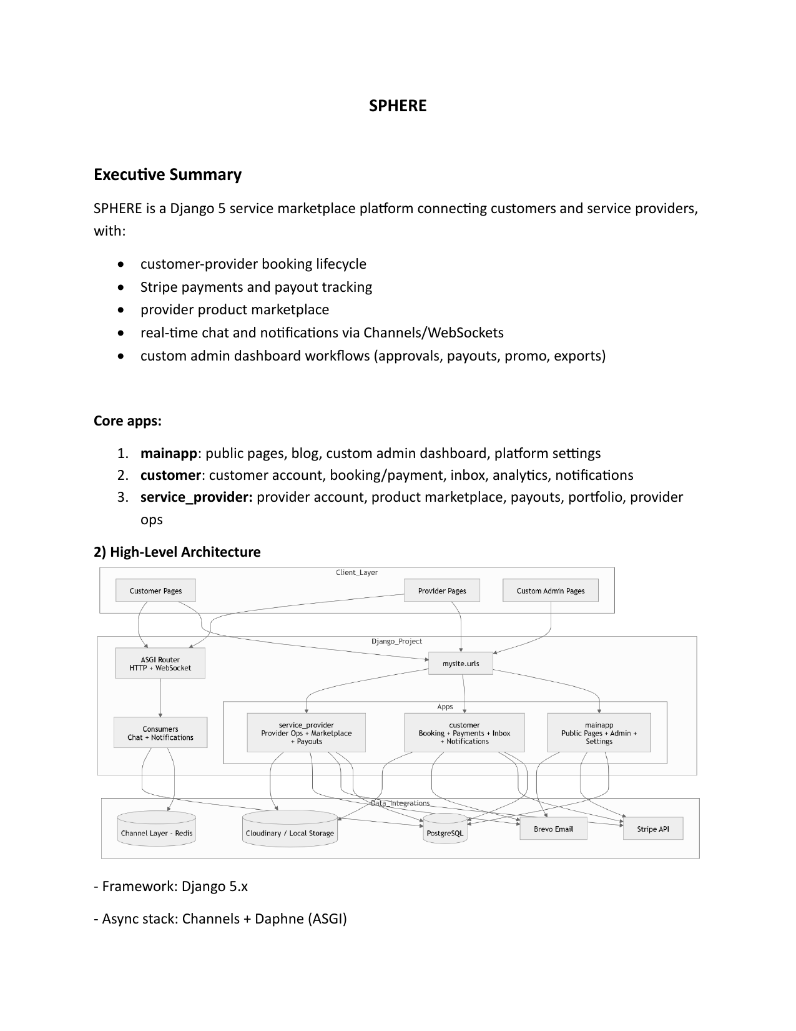
Portfolio value: SPHERE demonstrates the ability to combine commerce logic, real-time user interaction, and admin-heavy workflows into one cohesive web platform.

2. Pentabytex.com - Digital Agency Website
Pentabytex.com is a professional digital agency website focused on AI integration, web development, mobile app development, custom software, digital marketing, and e-commerce services.
What it delivers
- Lead-oriented homepage with strong calls to action
- Clear service positioning and trust-building content blocks
- Team presentation, testimonials, and booking flow
- WordPress-based structure for easy content management
- Marketing and service messaging aligned with business goals
Implementation highlights
- WordPress theme foundation with reusable templates and partials
- PHP, HTML, CSS, and JavaScript for front-end presentation
- Migration-friendly structure for scalable content updates
- Conversion-focused layout that supports client acquisition
- Suitable for agency branding, service storytelling, and portfolio growth

Portfolio value: Pentabytex.com shows how a business website can be designed to communicate professionalism, services, and credibility while remaining easy to maintain in a CMS environment.

